Decision Trees

A decision tree is a popular machine learning model that can be used for both classification and regression. It has multiple nodes- and each of these nodes serves a different purpose. The root node is the starting of the decision tree, and it is where a testing datapoint first enters the decision tree to be classified. Multiple questions are asked about the point at every internal node at each level of the decision tree, and on the basis of each of these questions, the point finally gets classified into one category of output label. 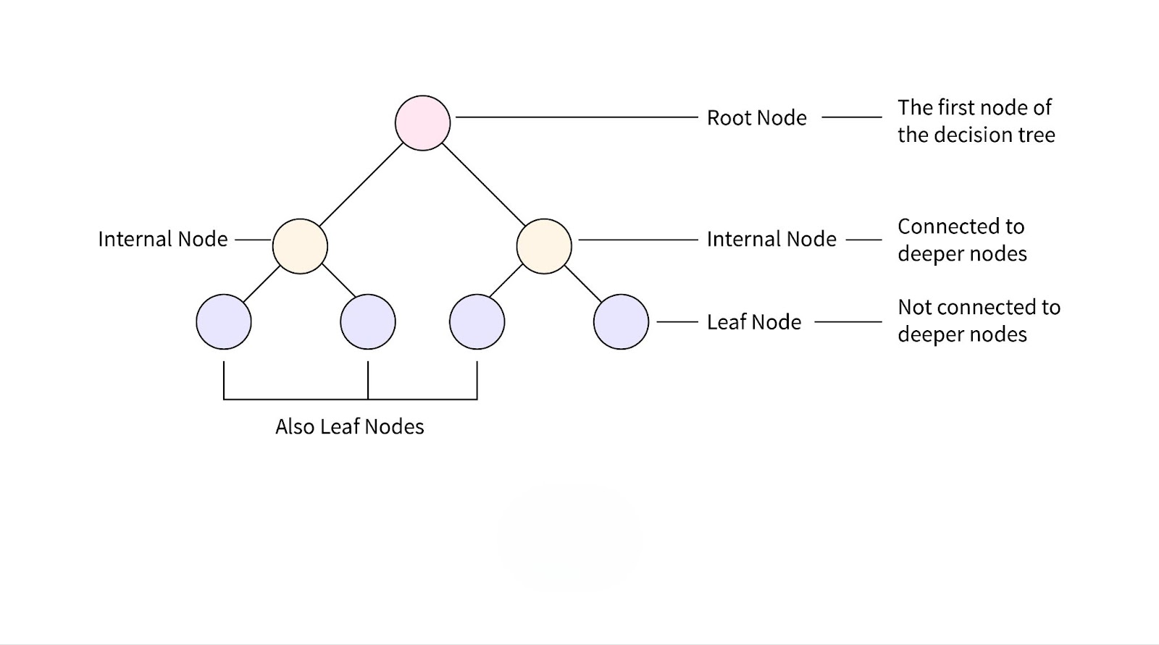
The decision tree is called a binary classification tree if there are only two possible output labels, while it is called a multiple classification tree if there are more than 2 possible output target labels.
Let’s first dive deep on the topic of classification trees, and we shall later cover regression trees.
Classification Trees:
During training of the classification tree, at the root node, we receive the entire training dataset. Our goal is to divide up these datapoints on any one of the features. We therefore iterate through all the values of all the columns and calculate at which threshold of what column, we receive the best possible split. The objective parameter for calculating this is the Information Gain (calculated by the Entropy/Gini Index in our case). Once we have the best threshold for the best feature, we apply an argument to split the data points on whether this feature of theirs is larger than or smaller than our decided threshold. In this way, we have separated the entire input training dataset into two sets, while at the same time establishing splitting conditions for the same. We apply this very logic to also split the dataset further at child nodes. At a pre-determined hyperparameter max_depth (say 10 levels), the splitting can be stopped and the decision tree can then be used for testing.
For testing, I used the F1 score.
F1 score is given by (2 * Precision * Recall) / (Precision + Recall)
Precision = TP / (TP + FP): Where precision tests how many of the model’s predicted True values were actually True with respect to its own guesses.
Recall = TP / (TP + FN): Where recall checks how well the model is able to identify all the True values with respect to the original dataset.
Another thing to note is that F1 score usually gives a number, like the R2 score. If we want a proper yes/no answer on the basis of an entire testing set, then we can use techniques to aggregate the output data, such as majority voting (for classification) or averaging (for regression).

Regression Trees:
While classification trees predict categorical values, regression trees predict continuous numerical values e.g. the cost of a house based on 10 different features.
For regression trees, even though the rough structure of the decision tree is the same, the best-split criteria is a little different. Where we used Gini Index/ Entropy to calculate the impurity of a node, here we use variance (as all the values are numeric). The main goal therefore becomes to reduce variance as much as possible with every single split.
While training, the variance of the root node (all target labels in the training dataset) is calculated. And then the best possible split is found such that the column and splitting threshold minimise this variance for child nodes. This process repeats till a pre-determined depth, or until the model has started creating too many leaf nodes with too little datapoints in each leaf node (classic sign of overfitting). The values of the leaf nodes are then calculated on the basis of the mean/median of all values in the leaf node.
After training, the model retains all these parameters. And then, the testing dataset is traversed through this established decision tree in order to get an output.

Overfitting- A Common Problem with Decision Trees:
Decision trees frequently learn the training data too well, and this means that the tree has overfit- i.e. it is not able to generalise well and predict test data accurately. To avoid overfitting, a variety of techniques can be used:
- Maximum Depth: As seen above, we can easily set a maximum depth hyperparameter on our decision tree in order to prevent it from overfitting. What this does is that it limits the decision trees from creating too many levels and asking too many questions to the datapoint, ultimately allowing somewhat error to creep into our training data accuracy for the sake of better generalisation towards test data.
- Pruning: Pruning basically refers to the cutting off of a branch of the decision tree and it is of two types: pre-pruning and post-pruning:
- Pre-Pruning- Pruning which is done while the tree is being built (trained). One example is to set the minimum samples per leaf, which avoids the decision tree from creating a lot of leaf nodes for just 1-1 point each. Another can be to set a minimum number of samples per split, which again sets a lower bound and prevents splitting scanty datasets. We can also set a maximum number of features to be taken into consideration (especially handy in case of random forests). This is good because some features are very powerful at creating good splits, while others may not be.
- Post-Pruning- After the tree is fully grown, post-pruning involves removing branches or nodes to improve the model's ability to generalize. An example is Cost-Complexity Pruning (CCP), which assigns a price to each subtree based on its accuracy and complexity, then selects the subtree with the lowest fee. Another is that of Reduced Error Pruning, which removes branches that do not significantly affect the overall accuracy. Finally, the Minimum Impurity Decrease pruning technique Prunes nodes if the decrease in impurity (Gini impurity or entropy) is beneath a certain threshold and therefore is not lucrative enough to create.

Sampling Techniques- How to Deal With Imbalanced Data?
We come across very imbalanced data frequently. Imbalanced data refers to data that has a majority and minority class- i.e. one target label is present in extremely high quantities when compared to the other target label. For example, in disease identification where 97% people getting tested do not have a disease and only 3% do. Or in another case, credit card defaults- where only about 5% of customers actually default while 95% do not.
An issue can arise due to this in our model. If we use imbalanced data to train any supervised machine learning model, the model might simply fail to learn the minority class well. This is an issue that might not even be immediately noticed- because the model will have 95% accuracy even if it predicts the majority class 100% of the time!
This is where the concept of sampling comes into play. Sampling is a technique that is used to deal with imbalance in data sets, and it is of two types: Undersampling and Oversampling.
Now, there are multiple oversampling and undersampling techniques we can use if we have a class imbalance. For example, let's say that our data is binary-classified. Then, having 80% samples as Type-0 and 20% samples as Type-1 would mean that a model trained on this data would have an inherently better understanding of Type-0, while it may be weaker at predicting Type-1.
Then we have two possible sampling techniques to deal with this:
- Undersampling- Eliminates the number of points of majority class randomly to enforce an equal class balance. However, this is not very compelling because it reduces the dataset without adding too much real value. Moreover, it could increase the sampling bias into our model- ie the model's parameters keep varying for different randomly-selected sample datasets that are picked.
- Oversampling- Generates synthetic points on the dataset based on currently existing points, and sometimes even creates more points from these newly-generated synthetic points.
a. The most basic way to oversample is to duplicate existing data points up to a certain amount. Even though it reduces training bias towards majority class, this method can prove to be too basic and lead to overfitting. Training it is also resource-intensive because the size of the training set has now increased drastically.
b. Another example of this technique is SMOTE, Synthetic Minority Oversampling Technique. SMOTE basically finds a pre-determined (e.g. 5) neighbours of all points in the minority class. Then, it draws a line between each existing point and any one of its randomly selected neighbours. On this line, SMOTE adds a new point (this could be in the exact centre between the two points, or it could be a randomly-found distance from either point). This fills up the sample space for Type-1 as well. However, SMOTE also has its problems. For example, it can be slow to train as it uses the KNN algorithm which is very resource-expensive. SMOTE does not work as well for categorical data (e.g. a bar graph of 0, 1, 2, 3 could generate a synthetic point between 2 & 3- which is simply not possible!)
c. The third example is ADASYN- which is Adaptive Synthetic Sampling. It basically interpolates the minority points nearer to the boundary as they are harder to classify normally. Adding more points to this boundary increases the dataset and hence understanding of these borderline points near the boundary.

